The first one is a screenshot about the Class hierarchy.
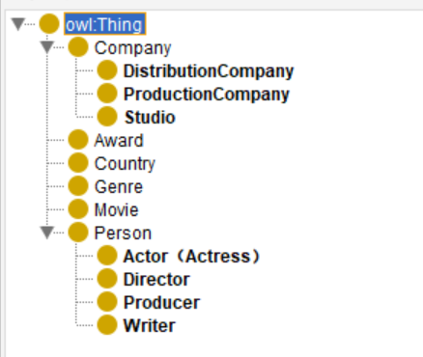
The this picture is the Class hierarchy .To consider the movies ,since we need
director, producer ,actor and writer all of them are person, so person is main class
and them are subclass. Also about company, Distribution Company, Production Company and Studio are the subclasses of it., And Award, Country, Genre, Movie, Person are also main class.

The second one is Object property hierarchy.
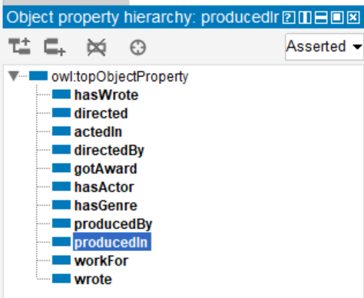
And directed and directedBy (inverse)since a direct directed a movie, a movie directedBy a direction, and in here I only choose functional in produceBy ,since
a movie only be directed by one director, but one director maybe has more than one
movie that he had directed. ActedIn and hasActor also (inverse) ,and no choose functional since almost movie has more than one actor, and each actor not only joins
one movie.”hasGenre””haswrote””producedBy””producedIn”just not fuctional and not inverse.”workFor” I add it since every person work for company, so the domain of it is
Company. “wrote” and hasWrote are inverse for each orther.

The next one is Data property hierarchy: 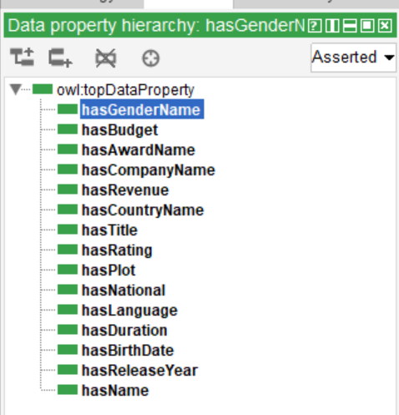
The data property hierarchy is rooted at `owl:topDataProperty`, under which all data properties required for the movie ontology are systematically organized. Person-related properties include `hasName` (person name), `hasBirthDate` (birth date), `hasGender` (currently named `hasGenderName` and requiring renaming), and `hasNational` (currently named `hasNational` and requiring renaming to `hasNationality` for nationality), which collectively describe the core information of person entities. Movie-related properties encompass `hasTitle` (movie title), `hasReleaseYear` (release year), `hasDuration` (duration), `hasPlot` (plot summary), `hasRating` (rating), `hasLanguage` (language), `hasBudget` (budget), and `hasRevenue` (revenue), which fully define the characteristics and metadata of movie entities. Furthermore, other key entities in the domain also possess dedicated properties: `hasCountryName` (country name), `hasCompanyName` (company name), and `hasAwardName` (award name). All properties strictly adhere to the `hasXxx` naming convention, ensuring consistency and readability of the ontology.
The last one sector of 1.2 is OWLviz and OntoGraf:
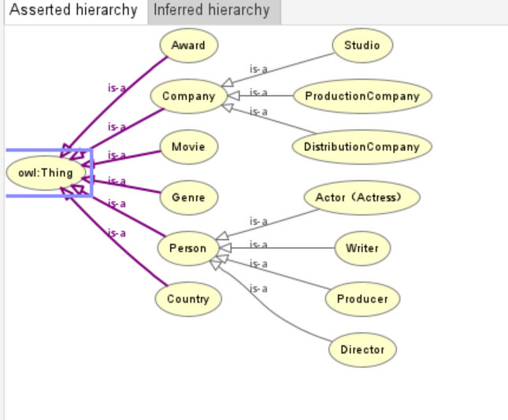 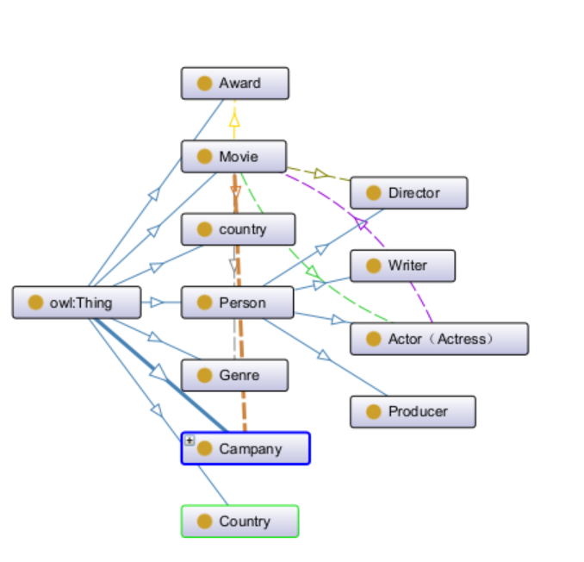 OWLViz focuses on visualizing the class hierarchy of an ontology in a tree diagram format, clearly displaying the inheritance relationships from the root class `owl:Thing` to its subclasses, which helps designers understand and validate the logical structure of the class system. OntoGraf, on the other hand, presents the complete association network among classes, properties, and individuals in a graph form, offering an intuitive visualization of the complex relational topology formed by object properties between entities, thereby aiding in grasping the structural connectivity and semantic interrelatedness of the ontology as a whole. These two tools are used complementarily in Protégé, supporting ontology design and analysis from the two dimensions of vertical inheritance and horizontal associations, respectively.

